## **What is DevOps?**

DevOps focuses on bringing together the development team and the operations team for the purpose of automating the project at every stage.

This way of practice is related to agile methodology and it mainly focuses on team communication, resource management, and teamwork. The main benefits of following this structure are the speed of development and resolving the issues at the production environment level, the stability of applications, and the innovation involved behind it.

## **DevOps Tools**

DevOps is a methodology aimed at increased productivity and quality of product development. The main tools used in this methodology are:

* Version Control System tools. Eg.: git.
* Continuous Integration tools. Eg.: Jenkins
* Continuous Testing tools. Eg.: Selenium
* Configuration Management and Deployment tools. Eg.:Puppet, Chef, Ansible
* Continuous Monitoring tool. Eg.: Grafana, Prometheus
* Containerization tools. Eg.: Docker

**Core operations of DevOps include:**

* Development
* Version Control (git)
* Testing (Selenium)
* Integration (Jenkins)
* Deployment (Ansible, Puppet, Chef)
* Delivery
* Configuration
* Monitoring (Grafana, Promethous)
* Containerization (Docker, Kubernetes)
* Feedback

### **What are some technical and business benefits of DevOps work culture?**

Technical benefits:

* Continuous software delivery
* Less complex problems to fix
* Faster bug resolution

Business benefits:

* Faster delivery of features for customer satisfaction
* More stable operating environments
* More time available to add product value

### **What is the use of SSH?**

SSH stands for Secure Shell and is an administrative protocol that lets users have access and control the remote servers over the Internet to work using the command line.

SSH also has a mechanism for remote user authentication, input communication between the client and the host, and sending the output back to the client.

### **What is configuration management?**

Configuration management (CM) is basically a practice of systematic handling of the changes in such a way that system does not lose its integrity over a period of time. This involves certain policies, techniques, procedures, and tools for evaluating change proposals, managing them, and tracking their progress along with maintaining appropriate documentation for the same.

CM helps in providing administrative and technical directions to the design and development of the appreciation.

**What is Version control?**

It is a system that records changes to a file or set of files over time so that you can recall specific versions later. Version control systems consist of a central shared repository where teammates can commit changes to a file or set of files.

### **What is CI? What is its purpose?**

CI or Continuous Integration is the process of compiling the entire code base, every time a member of the software development team checks the code, into the shared source code repository.

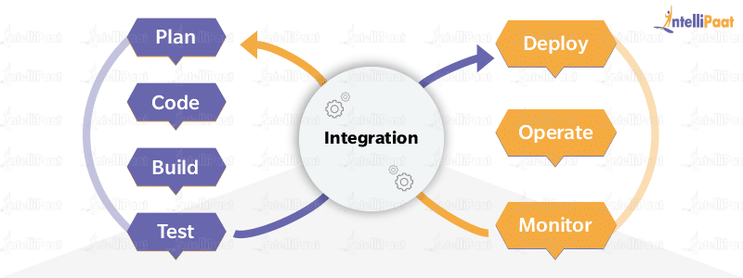

### **When do you use ‘git rebase’ instead of ‘git merge’?**

When we perform rebase of a feature branch onto the master branch, we move the base of the feature branch to the master branch’s ending point.

By performing a merge, we take the contents of the feature branch and integrate them with the master branch. As a result, only the master branch is changed, but the feature branch history remains the same. Merging adds a new commit to your history.

In order to see the history completely, the same way as it has happened, we should use merge. Merge preserves history, whereas rebase rewrites it.